**Question 1**

Given the following diagram design the Animal, Cat and Dog class:

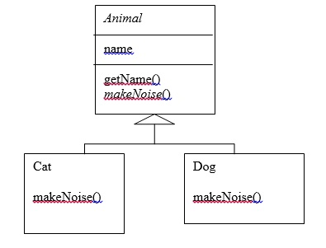

**Question 2**

Create a class called Employee whose objects are records for an employee. This class will be a derived class of the class Person which you will have to copy into a file of your own and compile. An employee record has an 1)employee's name (inherited from the class Person), 2)an annual salary represented as a single value of type double,3) a year the employee started work as a single value of type int and 4) a national insurance number, which is a value of type String.  
  
Your class should have a reasonable number of constructors and accessor methods, as well as an equals method. Write another class containing a main method to fully test your class definition.

**Question 3**

A class called Author is designed as follows:

* Three private member variables: name (String), email (String), and gender (char of either 'm' or 'f' - you might also use a boolean variable called isMale having value of true or false).
* A constructor to initialize the name, email and gender with the given values.  
  (There is no *default constructor*, as there is no default value for name, email and gender.)
* Public getters/setters: getName(), getEmail(), setEmail(), and getGender().  
  (There are no setters for name and gender, as these properties are not designed to be changed.)
* A toString() method that returns "*name* (*gender*) at *email*", e.g., "Tan Ah Teck (m) at ahTeck@somewhere.com".

Design a Book class. Assume that a book is written by one (and exactly one) author. The Book class contains the following members:

* Four private member variables: name (String), author (an *instance* of the Author class we have just created, assuming that each book has exactly one author), price (double), and qty (int).
* The public getters and setters: getName(), getAuthor(), getPrice(), setPrice(), getQty(), setQty().
* A toString() that returns "'book-name' by author-name (gender) at email". You could reuse the Author's toString() method, which returns "author-name (gender) at email".

**Question 4** - **Painting Shapes**

In this exercise you will develop a class hierarchy of shapes and write a program that computes the amount of paint needed to paint different objects. The hierarchy will consist of a parent class Shape with three derived classes - Sphere, Rectangle, and Cylinder. For the purposes of this exercise, the only attribute a shape will have is a name and the method of interest will be one that computes the area of the shape (surface area in the case of three-dimensional shapes). Do the following.

* 1. Write an abstract class Shape with the following properties:

An instance variable shapeName of type String

An abstract method area() ­

A toString method that returns the name of the shape

* 1. The file Sphere.java contains a class for a sphere which is a descendant of Shape. A sphere has a radius and its area (surface area) is given by the formula 4*PI*radius^2. Define similar classes for a rectangle and a cylinder. Both the Rectangle class and the Cylinder class are descendants of the Shape class. A rectangle is defined by its length and width and its area is length times width. A cylinder is defined by a radius and height and its area (surface area) is PI*radius^2*height. Define the toString method in a way similar to that for the Sphere class.
  2. The file Paint.java contains a class for a type of paint (which has a "coverage" and a method to compute the amount of paint needed to paint a shape). Correct the return statement in the amount method so the correct amount will be returned. Use the fact that the amount of paint needed is the area of the shape divided by the coverage for the paint. (NOTE: Leave the print statement - it is there for illustration purposes, so you can see the method operating on different types of Shape objects.)
  3. The file PaintThings.java contains a program that computes the amount of paint needed to paint various shapes. A paint object has been instantiated. Add the following to complete the program:

Instantiate the three shape objects: deck to be a 20 by 35 foot rectangle, bigBall to be a sphere of radius 15, and tank to be a cylinder of radius 10 and height 30. Make the appropriate method calls to assign the correct values to the three amount variables.

­

Run the program and test it. You should see polymorphism in action as the amount method computes the amount of paint for various shapes.

**Question 5**

Write the superclass Shape and its subclasses Circle, Rectangle and Square, as shown in the diagram.

## 

In this exercise, Shape shall be defined as an abstract class, which contains:

* Two protected instance variables color(String) and filled(boolean). The protected variables can be accessed by its subclasses and classes. They are denoted with a '#' sign in the diagram.
* Getter and setter for all the instance variables, and toString().
* Two abstract methods getArea() and getPerimeter() (shown in italics in the diagram).

The subclasses Circle and Rectangle shall *override* the abstract methods getArea() and getPerimeter() and provide the proper implementation. They also *override* the toString().

**Question 6**

Suppose that we have a set of objects with some common behaviors: they could move up, down, left or right. The exact behaviors (such as how to move and how far to move) depend on the objects themselves. One common way to model these common behaviors is to define an interface called Movable, with abstract methods moveUp(), moveDown(), moveLeft() and moveRight(). The classes that implement the Movable interface will provide actual implementation to these abstract methods.

For the MovablePoint class, declare the instance variable x, y, xSpeed and ySpeed. For the MovableCircle class, use a MovablePoint to represent its center (which contains four variable x, y, xSpeed and ySpeed). In other words, the MovableCircle composes a MovablePoint, and its radius.

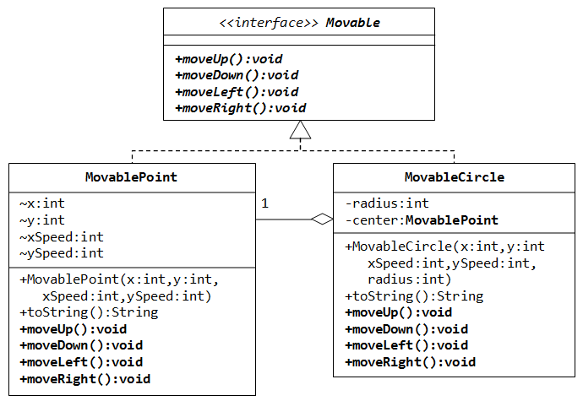

**Question 7**

1. Write the interface called GeometricObject, which declares two abstract methods: getParameter() and getArea().
2. Write the implementation class Circle, with a protected variable radius, which implements the interface GeometricObject.
3. Write a test program called TestCircle to test the methods defined in Circle.
4. The class ResizableCircle is defined as a subclass of the class Circle, which also implements an interface called Resizable, as shown in diagram. The interface Resizable declares an abstract method resize(), which modifies the dimension (such as radius) by the given percentage. Write the interface Resizable and the class ResizableCircle.
5. Write a test program called TestResizableCircle to test the methods defined in ResizableCircle.

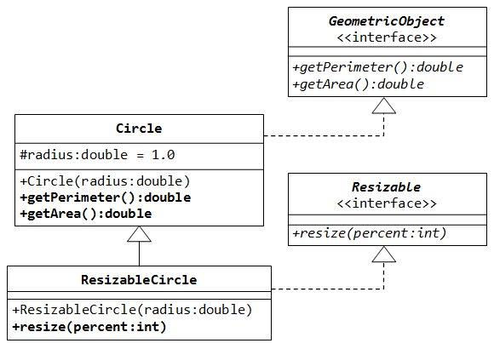

**Task 8**

Write an abstract class ‘**Instrument’** which will have abstract method ‘**play’**, ‘**adjust’** & concrete method ‘**compose’**.

Use the abstract class ‘Instrument’ to create class ‘**Guitar’**, ‘**Keyboard’** & ‘**Violin’**.

Create instance (object) of every classes invoking(calling) every method. The method will print any message with ‘Instrument name’ and ‘Purpose’,

* The method ‘play’ for ‘Violin’ class will print “In the playing method of Violin”

https://docs.oracle.com/javase/tutorial/java/IandI/abstract.html

**Task 9**

Write a java application as follows:

Create a Student Interface ‘**StInterface’** with the methods ‘**setName’**, ‘**setID’**, ‘**getName’** **and ‘getID’**.

Create the class ‘**Student’** with ‘name’, ‘id’ and ‘address field’ implementing the ‘**StInterface’** to manipulate the Student information using the necessary methods.

Create an array of objects of **Student**. Then input the number of students to allocate student array dynamically and take Student information. Now print the student list alphabetically.

https://docs.oracle.com/javase/tutorial/java/concepts/interface.html

**Task 10**

**Mutant Flatworld Explorers**

http://online-judge.uva.es/p/v1/118.html

**Hint:** It is similar to Task 1 and 2 but here you will have to maintain a two dimensional character array

## Background

Robotics, robot motion planning, and machine learning are areas that cross the boundaries of many of the subdisciplines that comprise Computer Science: artificial intelligence, algorithms and complexity, electrical and mechanical engineering to name a few. In addition, robots as ``turtles'' (inspired by work by Papert, Abelson, and diSessa) and as ``beeper-pickers'' (inspired by work by Pattis) have been studied and used by students as an introduction to programming for many years.

This problem involves determining the position of a robot exploring a pre-Columbian flat world.

## The Problem

Given the dimensions of a rectangular grid and a sequence of robot positions and instructions, you are to write a program that determines for each sequence of robot positions and instructions the final position of the robot.

A robot position consists of a grid coordinate (a pair of integers: x-coordinate followed by y-coordinate) and an orientation (N,S,E,W for north, south, east, and west). A robot instruction is a string of the letters 'L', 'R', and 'F' which represent, respectively, the instructions:

* Left: the robot turns left 90 degrees and remains on the current grid point.
* Right: the robot turns right 90 degrees and remains on the current grid point.
* Forward: the robot moves forward one grid point in the direction of the current orientation and mantains the same orientation.

The direction North corresponds to the direction from grid point (*x*,*y*) to grid point (*x*,*y*+1).

Since the grid is rectangular and bounded, a robot that moves ``off'' an edge of the grid is lost forever. However, lost robots leave a robot ``scent'' that prohibits future robots from dropping off the world at the same grid point. The scent is left at the last grid position the robot occupied before disappearing over the edge. An instruction to move ``off'' the world from a grid point from which a robot has been previously lost is simply ignored by the current robot.

## Hint: For your convenience, you may mark cells having the scent with ‘X’ or any character you like to mean forbidden cells.

## The Input

The first line of input is the upper-right coordinates of the rectangular world, the lower-left coordinates are assumed to be 0,0.

The remaining input consists of a sequence of robot positions and instructions (two lines per robot). A position consists of two integers specifying the initial coordinates of the robot and an orientation (N,S,E,W), all separated by white space on one line. A robot instruction is a string of the letters 'L', 'R', and 'F' on one line.

Each robot is processed sequentially, i.e., finishes executing the robot instructions before the next robot begins execution.

Input is terminated by end-of-file.

You may assume that all initial robot positions are within the bounds of the specified grid. The maximum value for any coordinate is 50. All instruction strings will be less than 100 characters in length.

## The Output

For each robot position/instruction in the input, the output should indicate the final grid position and orientation of the robot. If a robot falls off the edge of the grid the word ``LOST'' should be printed after the position and orientation.

## Sample Input

5 3

1 1 E

RFRFRFRF

3 2 N

FRRFLLFFRRFLL

0 3 W

LLFFFLFLFL

## Sample Output

1 1 E

3 3 N LOST

2 3 S

**Task 11**

Given Example:

Scanner s = new Scanner (System.in);

int x = s.nextInt();

int y = s.nextInt();

int z = s.nextInt();

System.out.println(x+y+z);

* Create a file named **a.txt** in your C drive root
* Write three numbers ( 14 15 16) on three separate lines
* Modify the given example above by
  + Adding import **java.io.*;** at the top (needed for the **File** class)
  + Replacing **Scanner s = new Scanner (System.in);**

with **String amarFileNameAndLocation = "c:\\a.txt";**

**File amarFile = new File ( amarFileNameAndLocation );**

**Scanner s =new Scanner (amarFile) );**

**Or, in short**

with **Scanner s =new Scanner (new File("c:\\a.txt") );**

* + Replacing **each int x = s.nextInt()**

with **String ektaLine;**

**ektaLine = s.nextLine();**

**int x = Integer.parseInt(ektaLine);**

* Run your program. It should give 45 as output.

**Hint**: Following two lines prints 12 on the screen:

int x=Integer.parseInt(**"**5**"**);

int y=Integer.parseInt(**"**7**"**);

System.out.println(x+y);

**Further reading:**

https://docs.oracle.com/javase/8/docs/api/java/lang/Integer.html#parseInt-java.lang.String-

http://192.168.0.84/bucc/javadoc/api/java/lang/Integer.html#parseInt(java.lang.String)

**Task 12**

Modify your **Task 11** so that if a.txt file contains any number of lines each with one number, your program should sum all numbers and give correct output. **Hint:** hasNextLine() method tells if the file has any line left. For more, read

https://docs.oracle.com/javase/8/docs/api/java/util/class-use/Scanner.html

http://192.168.0.84/bucc/javadoc/api/java/util/Scanner.html

**Example:**

String line;

while(s.hasNextLine()){

line = s.nextLine();

System.out.println( line );

}

**Task 13**

Modify your **Task 11** so that your program takes input from b.txt file. That file will contain three numbers (16 17 18) but on the same line. Output should be 51. **Hint:** use the method **next() and hasNext()** instead of **nextLine()** and **hasNextLine();**

**Task 14**

Modify your **Task 11** so that your program takes input from b.txt file. That file will contain three numbers (16 17 18) but on the same line. Output should be 51. **Hint:** use the method **nextInt() and hasNextInt()** instead of **nextLine()** and **hasNextLine();**

**Task 15**

Write a program that asks the user for file name. Then prints the whole file on screen line by line. Hint: read each line and immediately print that line.

**Task 16**

Given a file name, delete that file. **Hint:** read

https://docs.oracle.com/javase/8/docs/api/java/io/File.html#delete--

http://192.168.0.84/bucc/javadoc/api/java/io/File.html#delete()

http://www.java2s.com/Code/Java/File-Input-Output/DeletefileusingJavaIOAPI.htm

**Task 17**

Given a line as keyboard input in small letters, print the next alphabet in sequence for each alphabet found in the input

Sample Input 1:

abcd

Sample output 1:

bcde

Sample Input 2:

the cowz

Sample output 2:

uif dpxa

**Task 18**

Given a line as keyboard input in small letters, do the opposite of Task17

Sample Input 1:

bcde

Sample output 1:

abcd

Sample Input 2:

uif dpx

Sample output 2:

the cow

**Task 19**

One of my GRE (Graduate Record Exam.) question was about “Too much emphasis is placed on role models. Instead of copying others, people should learn to think and act independently and thus make the choices that are best for them.”. I answered that role models are necessary but instead of acting like them, we have to learn what contributed to their success (thoughts, education, exploration) and what did not (e.g. life style)

I came to know about Dr. Regina Dugan from MSA probably during Spring 2009. She is the director of Defense Advanced Research Projects Agency (DARPA), US Military. To inspire yourself towards self learning, read on her from

* http://www.darpa.mil/directorbio.html
* http://www.duganventures.com/team.html
* http://topics.nytimes.com/topics/reference/timestopics/people/d/regina_e_dugan/index.html

**Task 20**

Learning

* command line I/O (Input and output) redirection using >, >>
* usage of batch files (extensions bat or cmd)